Python-Based ATM Management System (User & Admin Login)

Python.file:

Screenshot:
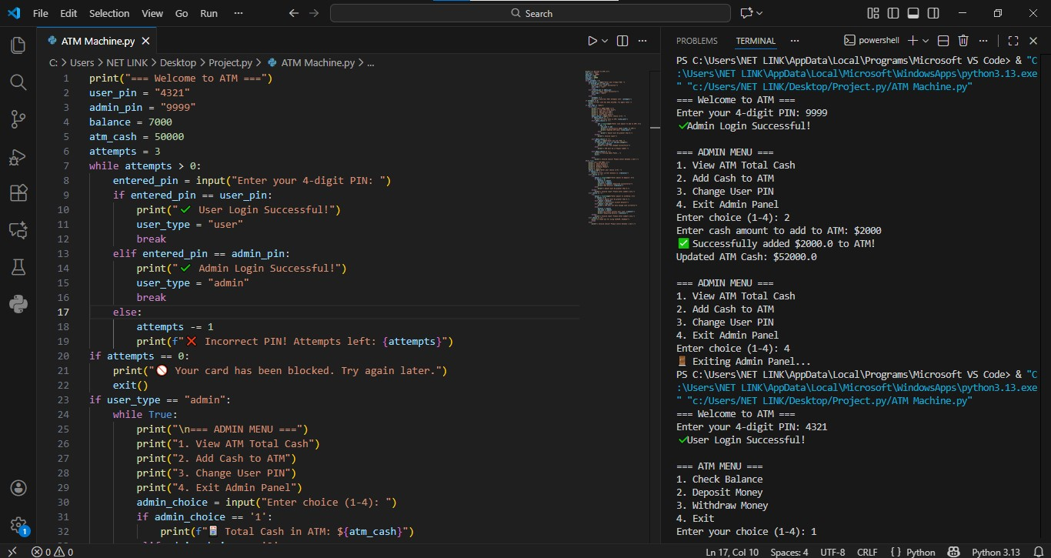

Details:
This Python program simulates a simple ATM system with two types of access:
- User
- Admin
It uses:
- PIN-based authentication
- Limited login attempts
- Separate menus for Admin and User
- Basic banking operations like check balance, deposit, withdraw
- ATM cash management by the admin
The program runs in the terminal and uses loops, conditions, and exception handling to work smoothly.

Main Components:
- User PIN: 4321
- Admin PIN: 9999
- Initial User Balance: $7000
- ATM Cash Available: $50000
- Maximum Login Attempts: 3

Working of the Code:

1. Program Start:
- Displays a welcome message.
- Initializes PINs, balance, ATM cash, and login attempts.

2. PIN Authentication:
- User gets 3 attempts to enter the correct PIN.
- If:
  - User PIN → User menu opens
  - Admin PIN → Admin menu opens
  - Wrong PIN → Attempts decrease
- After 3 failed attempts, the card is blocked and the program exits.

3. Admin Panel (If Admin Logs In):
Admin can perform the following actions:
- View ATM Total Cash
  - Displays current cash available in the ATM.
- Add Cash to ATM
  - Admin can add money to ATM cash.
  - Only positive values are accepted.
- Change User PIN
  - Allows admin to set a new 4-digit user PIN.
- Exit Admin Panel
  - Ends the program.
The admin menu runs in a loop until the admin exits.

4. User ATM Menu:
After successful user login, the ATM menu appears:
- Check Balance
  - Shows the user’s current account balance.
- Deposit Money
  - Adds money to both:

    - User balance
    - ATM cash
- Withdraw Money
  - Checks:
    - Amount > 0
    - Sufficient user balance
    - Sufficient ATM cash
  - If valid, cash is withdrawn successfully.
- Exit
  - Ends the ATM session.

5. Error Handling:
- Uses try-except blocks to prevent crashes from invalid (non-numeric) inputs.
- Displays user-friendly error messages.

